

*Table of Contents:*

1. Team……………………………………………………………………………………………………………………..…2
2. Work on the project……………………………………………………………………………………………2
3. Difficulties encountered…………………………………………………………………………………….3
4. Means used…………………………………………………………………………………………………………….3
5. Conclusion……………………………………………………………………………………………………………….3
6. Team:

|  |  |
| --- | --- |
| № | Roles in the team |
| 1. | Radomir Aleksandrov – Scrum Trainer – RAAleksandrov21@codingburgas.bg |
| 2. | Stanimir Popov – QA Engineer - SSPopov21@codingburgas.bg |
| 3. | Enis Mustafa - Back-end Developer - EEMustafa21@codingburgas.bg |
| 4. | Stilian Georgiev - Front-end Developer - SZGeorgiev21@codingburgas.bg |

1. 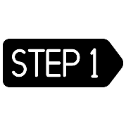Work on the project:

Getting a basic idea of ​​the project:

We got together in a meeting and discussed ideas and in the end we all settled on one opinion.

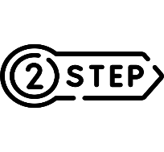

Early and late stages of the project:

We made a schedule, we worked together, everyone helped with everything. The last few days have been hard at work.

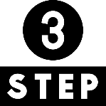

Presentation of the project:

We were adding the final edits to our project and all that was left was to present it.

1. Difficulties encountered

|  |  |
| --- | --- |
| Making of the team | 9/10 |
| Making the code | 9/10 |
| Distributing the roles | 10/10 |
| Communication | 10/10 |

1. Means used

|  |  |
| --- | --- |
| Word | Tool for making the documentation |
| PowerPoint | Tool for making the presentation |
| Teams | Communication tool |
| Paint | Making the team logo |
| Excel | Tool for making the QA table |
| Visual Studio | Tool for writing the code |
| GitHub |  |

1. Conclusion

We learned a lot of new things. We improved our teamwork. We had fun and worked hard on this project activity.